### Semester Two Examination,2018

### Question/Answer booklet

# MATHEMATICS SPECIALIST

**UNITs 3 & 4**

## Section One:

## Calculator-free

|  |
| --- |

Your Name

Your Teacher’s Name

## Time allowed for this section

Reading time before commencing work: five minutes

Working time: fifty minutes

## Materials required/recommended for this section

***To be provided by the supervisor***

This Question/Answer booklet

Formula sheet

***To be provided by the candidate***

Standard items: pens (blue/black preferred), pencils (including coloured), sharpener, correction fluid/tape, eraser, ruler, highlighters

Special items: nil

## Important note to candidates

No other items may be taken into the examination room. It is **your** responsibility to ensure that you do not have any unauthorised material. If you have any unauthorised material with you, hand it to the supervisor **before** reading any further.

| Question | Total Marks | Awarded Marks |
| --- | --- | --- |
| 1 | 4 |  |
| 2 | 6 |  |
| 3 | 8 |  |
| 4 | 6 |  |
| 5 | 6 |  |
| 6 | 6 |  |
| 7 | 9 |  |
| 8 | 6 |  |

**Structure of this paper**

| Section | Number of questions available | Number of questions to be answered | Working time (minutes) | Marks available | Percentage of examination |
| --- | --- | --- | --- | --- | --- |
| Section One:  Calculator-free | 8 | 8 | 50 | 51 | 35 |
| Section Two:  Calculator-assumed | 12 | 12 | 100 | 100 | 65 |
|  |  |  |  | **Total** | 100 |

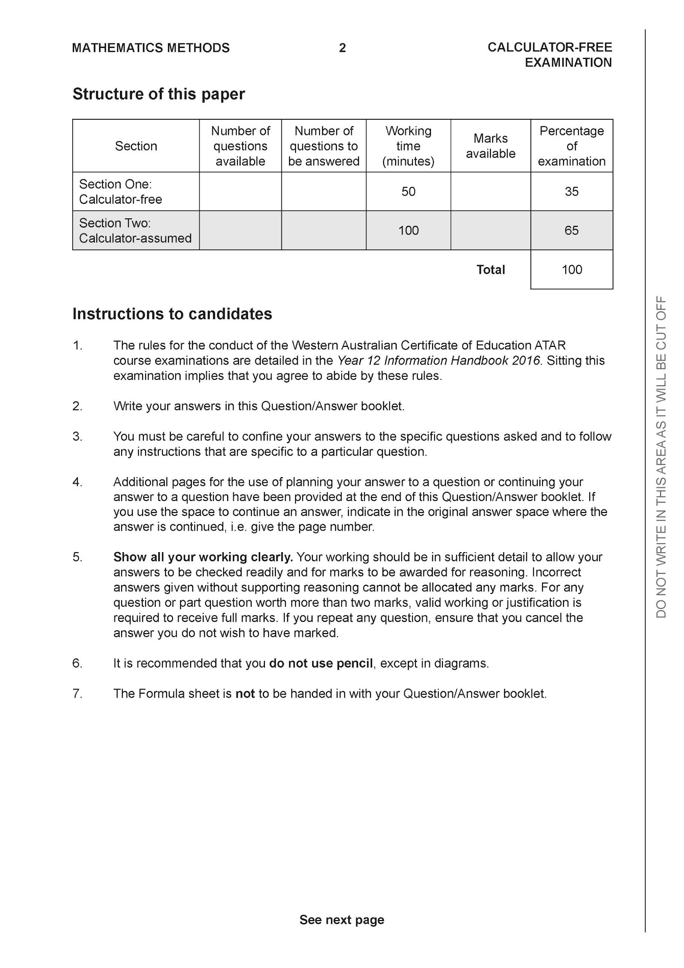

**Section One: Calculator-free (51 Marks)**

This section has **eight (8)** questions. Answer **all** questions. Write your answers in the spaces provided.

Spare pages are included at the end of this booklet. They can be used for planning your responses and/or as additional space if required to continue an answer.

● Planning: If you use the spare pages for planning, indicate this clearly at the top of the page.

● Continuing an answer: If you need to use the space to continue an answer, indicate in the original answer space where the answer is continued, i.e. give the page number. Fill in the number of the question that you are continuing to answer at the top of the page.

Working time: 50 minutes.

**Question 1 (4 marks)**

Consider the function where are real constants.



Given that are factors of , determine the values of .



**Question 2 (3 &3 = 6 marks)**

Consider the definite integral



1. By using the substitution show that and state the values of .



1. Hence evaluate exactly.



**Question 3 (3, 3 & 2 = 8 marks)**

Consider , which is graphed below.

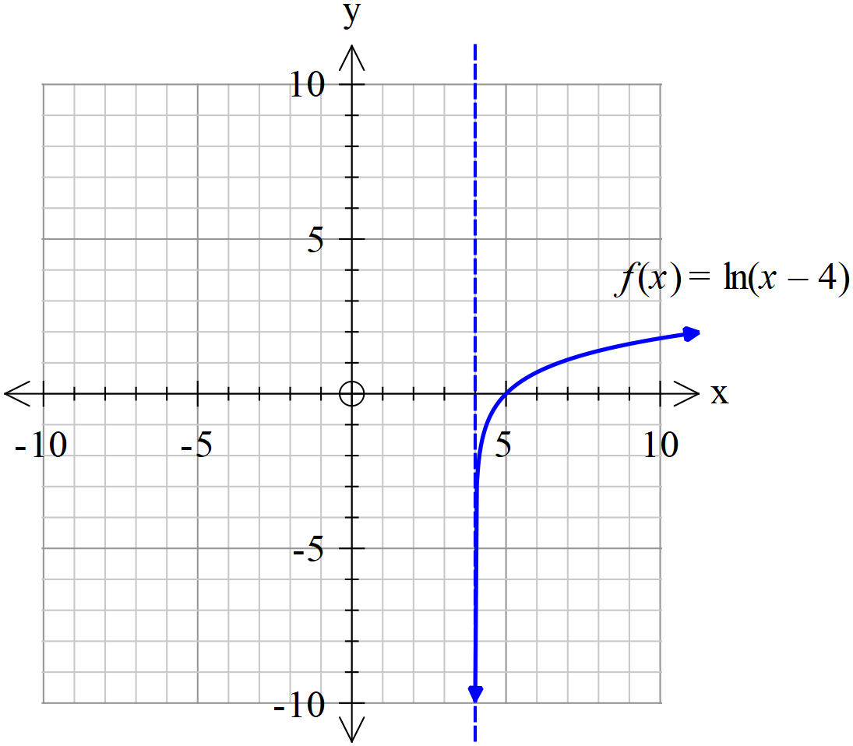

1. Sketch the inverse of on the axes above.



1. Determine the rule for stating the domain and range.



1. Determine the rule for and state the largest possible domain for it to exist.



**Question 4 (2, 3 & 1= 6 marks)**

Consider the functions where and .



1. Determine the natural domain and range of .



1. Does exist over the natural domain of? If not then restrict the domain of to give the largest possible domain for to exist.



1. State the rule for and the corresponding range for your answer to (b).



**Question 5 (3 & 3 = 6 marks)**

Solve for in the following.



(a) given that contains the point (3 marks)



(b) given that contains the point (3 marks)



**Question 6 (6 marks)**

Determine the following integral.



**Question 7 (2, 4 & 3 =9 marks)**

Consider a rectangular box with points ,,, & all opposite faces are congruent and parallel.

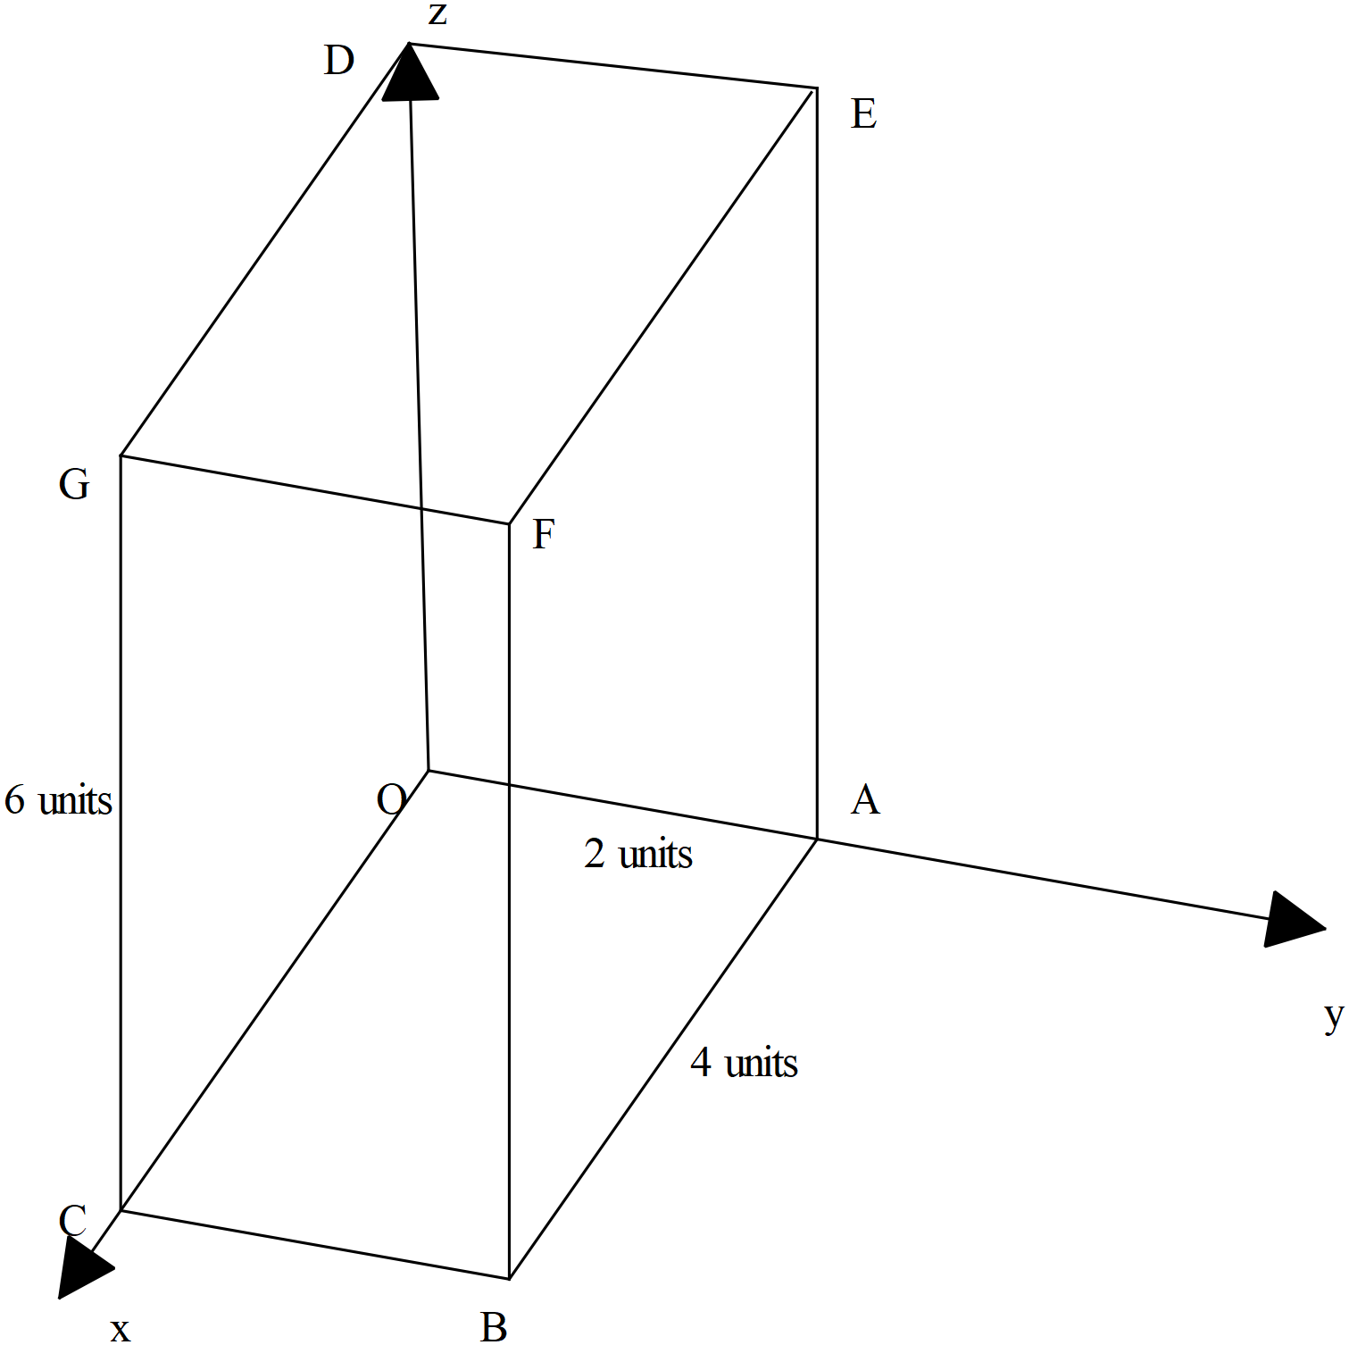

1. Determine the vectors , the diagonals of the rectangular box.



(2 marks)

1. Prove that the diagonals bisect each other, i.e meet at their midpoints.



(4 marks)

Q7 cont-

1. Determine the cartesian equation of the plane that contains the points .



(3 marks)

**Question 8 (6 marks)**

Consider the area enclosed between ,the lines and the axis.



If this area is revolved around the axis, a three dimensional object is formed.



Determine the volume of this three dimensional object.

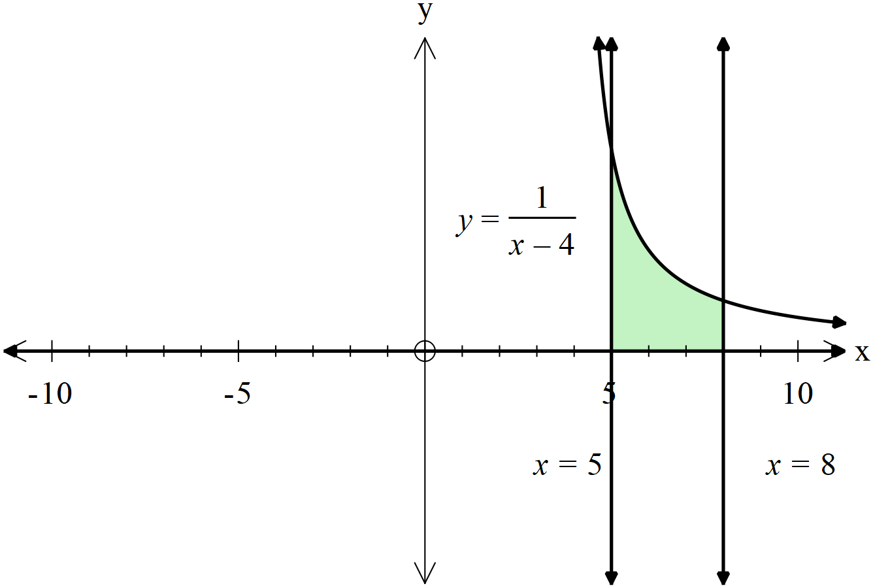

**Additional working space**

Question number:

**Additional working space**

Question number: